How Automated Reminders Helped Hylobiz Customers in Collecting Payments Faster – A Case Study

Timely Invoice Payment is a nightmare!
Even though you can send a digital invoice, the buyer yet tend to forget or miss paying the dues on time. Ask any Freelancer, Entrepreneur, Accountant or Sales person – they would have tales of tell.
While building our product we realized one thing – you need to be consistent in your efforts, and the automated reminders from Hylobiz is a tool that can make you consistent without much hassle. And you could be getting the invoices payments on time.
In fact our clients who used the reminders 55% of them were able to get the payment within 0-3 days of reminders sent.
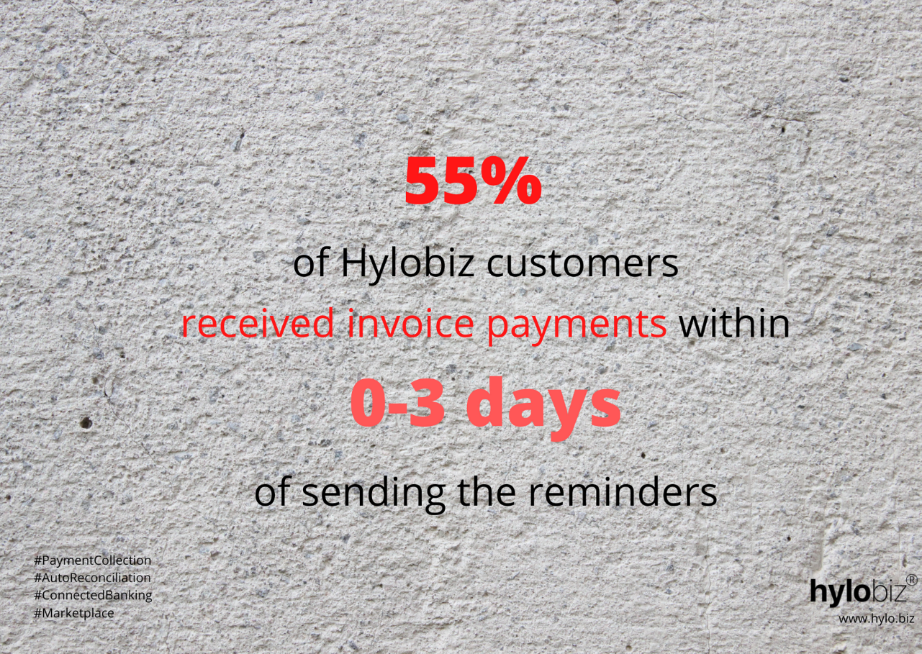

The Importance of Reminders
Hylobiz aim to empower businesses and SME’s , one of the thing that can take them to growth is timely Payments. But how can that be done was the question?

Just sending a digital invoice to the buyer, followed by manual efforts of phone call do not work efficiently. We wanted to empower the SME’s with a reminder and convenience to the buyer to pay his invoice.
That’s when we introduced – Powerful Automated Reminders feature that is equipped with one click payment link.

In fact our customers has tested and proven the capability of the feature.

What we did –
- We gathered the data from June-2020 to Feb 2021. Total number of invoices = 49330
- We analysed the invoices whose status was Paid/Partially Paid = 7580
- We retrieved invoices for which reminders were sent = 2089
- Then we analysed how many reminders were sent by the seller and categorized them into
  - Payment done on same day [Day0] of reminder sent
  - Payment done on same day [Day1] of reminder sent
  - Payment done on same day [Day2] of reminder sent
  - Payment done on same day [Day3] of reminder sent
  - Payment done on same day [Day4] of reminder sent
  - Payment done on same day [Day5] of reminder sent
  - Payment done on same day [Day6] of reminder sent

We were amazed to see that 56% of our customers who sent reminder /scheduled reminder received payment for the invoices within the Day 0, 1,2 and 3rd day of reminder sent.
And almost 25% of Hylobiz customers received the invoice payment within Day 4, 5,6 and 7th day of reminder sent.

If we break the data even further

Hylobiz with Automated Reminders Feature Making Invoice Payment Faster by 12%

Like our customers, you can also get paid on time!

